**BİL420/BİL520 Siber Güvenliğe Giriş**

Ödev-1

*Ad Soyadı, No: Fatih Arslan Tugay, 181101008*

**RSA Public-Key Encryption and Digital Signature Applications:**

* README file about code is in ‘rsa’ path with this document’s zip.

**Task 1:**

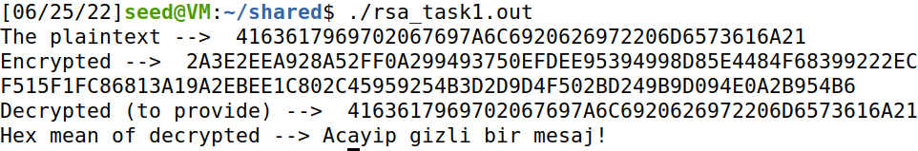

**Task 2:**

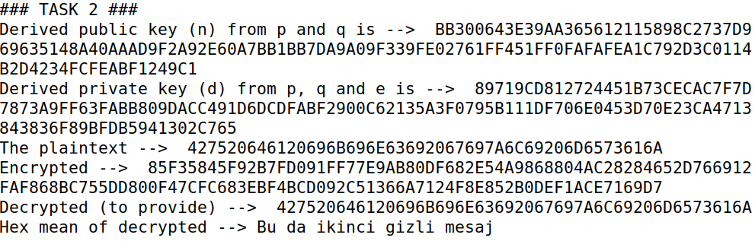

**Task 3:**

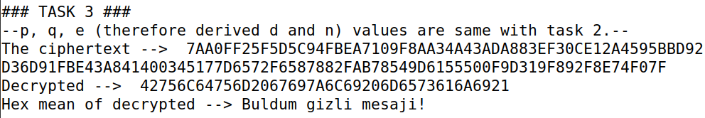

**Task 4:**

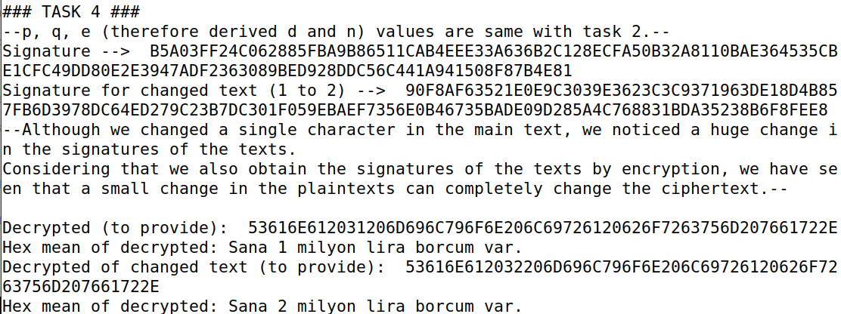

**Task 5:**

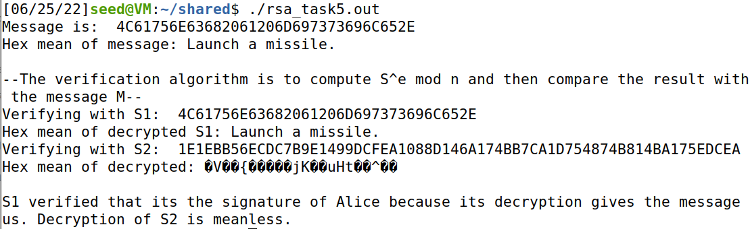

**Crypto and Symmetric Key Encryption Applications:**

* Files of each task are in ‘crypto’ path with this document’s zip.

**Task 1:**

* **I convert the ciphertext to upper and I analysed the text. I change single letter ‘D’ with ‘a’ and ‘DSS?’ with ‘all?’ first. And changed ‘EY’ to ‘of’, ‘DAC’ to ‘and’ and ‘RUF’ to ‘the’. Other letters opened quickly later.**

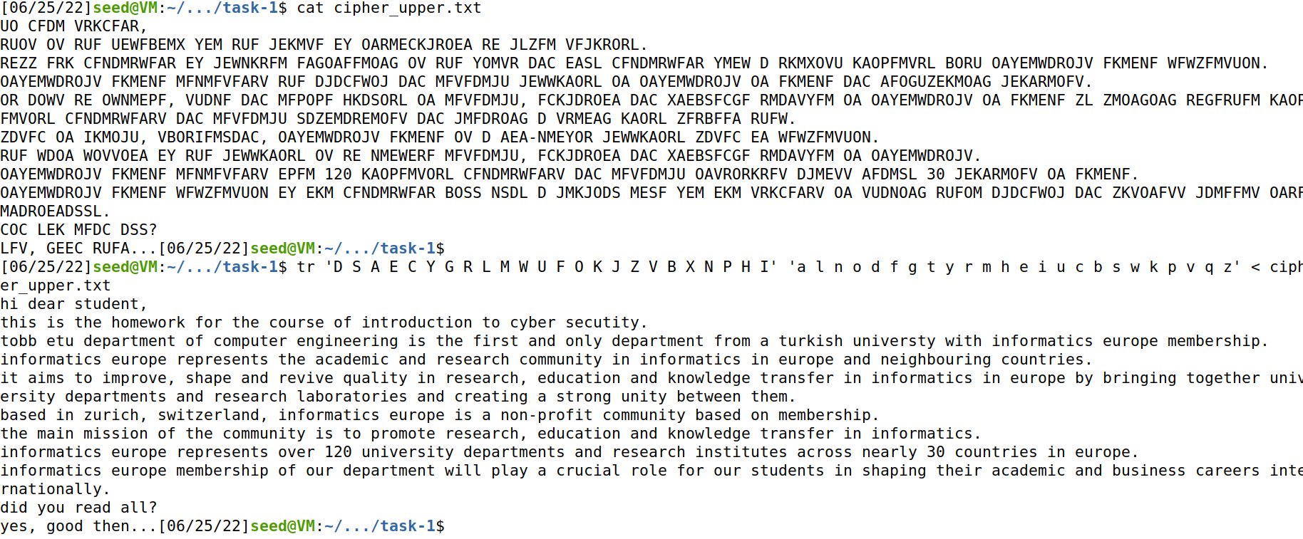

**Task 2:**

* **Part 1: Encrypting with three different ciphers (encrypted images and images obtained with ‘cat’ command will be sended with this file)**
  + **AES-128-CFB**

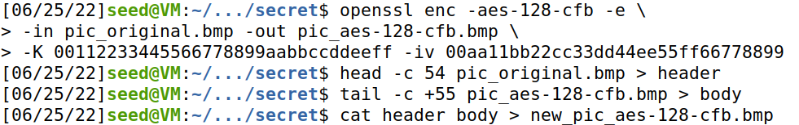

* + **AES-128-CBC**

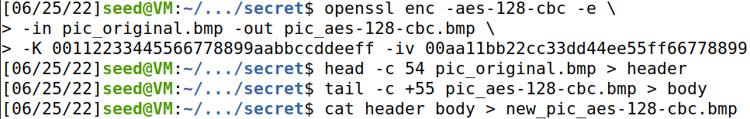

* + **DES-CBC**

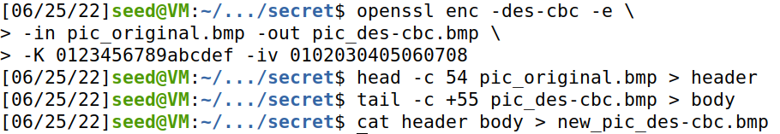

* **Part 2: Encrypting with ECB and CBC two images, then compare methods**
  + **ECB and CBC on given image (pic_original.bmp)**

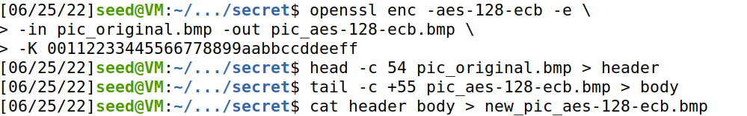

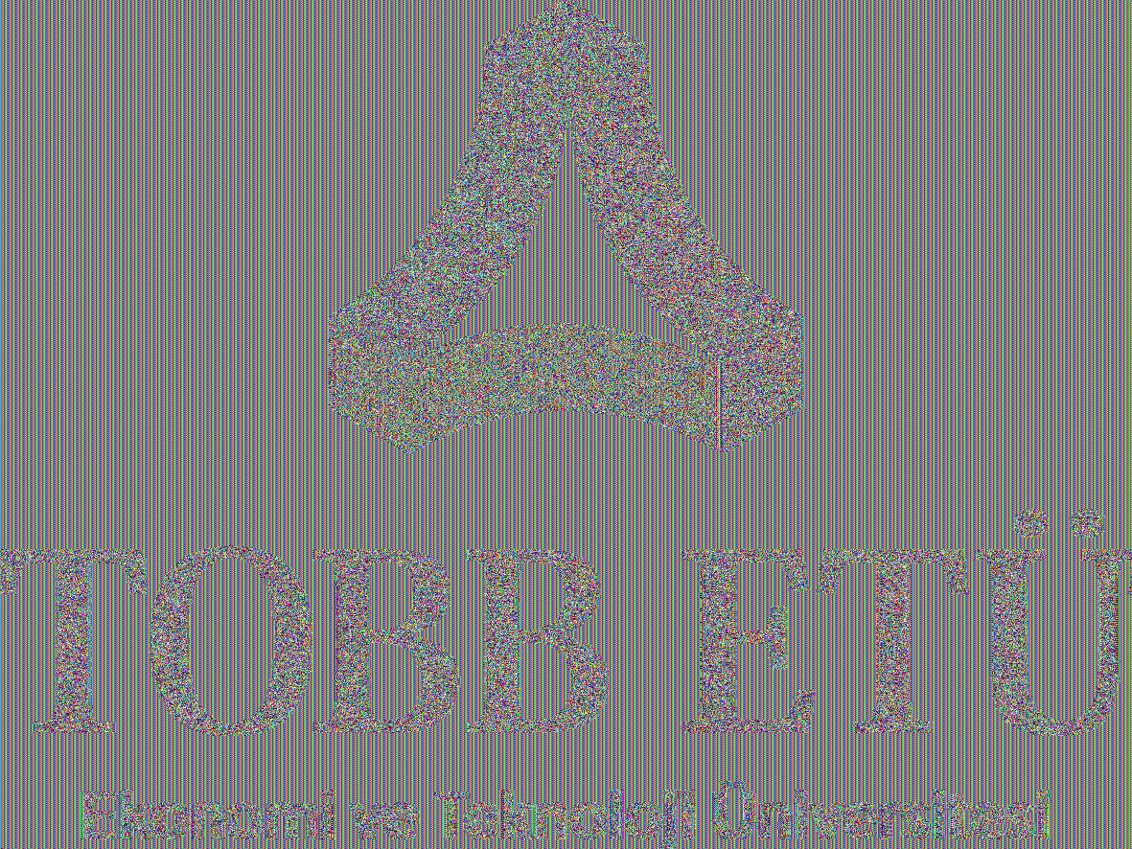

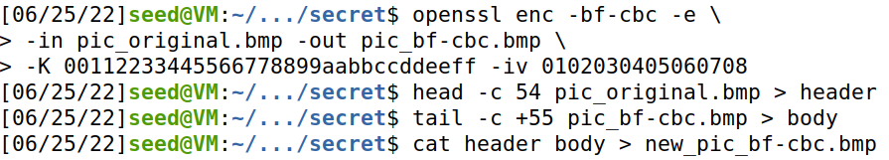



* + **ECB and CBC on chosen image (besiktas.bmp)**

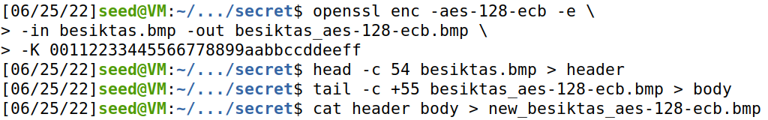

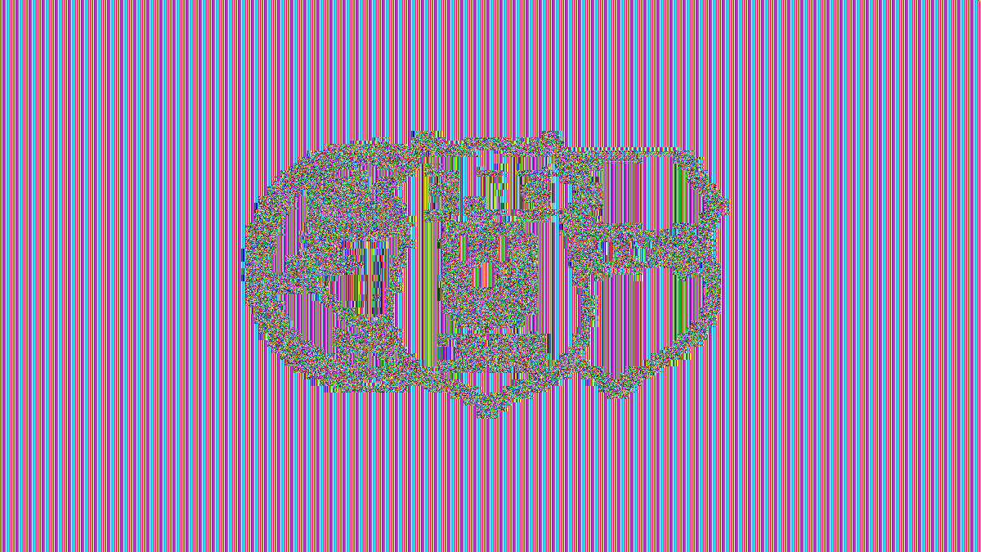

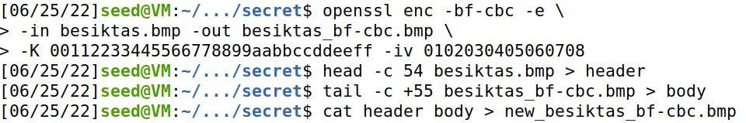



* + **Comparing ECB and CBC results**

Making out the shapes of encrypted image with using ECB encryption is very easy. When using CBC, I cannot see any relationship between original image and encrypted image. When I repeat the scenario for chosen image (besiktas.bmp), the result were same. The shapes of my encrypted image is open to see when I use ECB.

**Task 3:**

* **Assumption**

We know effects of single bit errors on i’th block on modes. In ECB and OFB, it causes a bit error in i’th block. In CBC and CFB, single bit error in a block will cause failure of decryption in subsequent block because they chains all blocks together by XORing the output of the encryption block with the next plaintext block.

In the light of this information, we can say that the most error loss will be in CFB and CBC modes. It is clear that in ECB and OFB modes, there will be minimal loss (In OFB with one bit).

* **I created a text file includes “Gençliğe Hitabe”. It is exactly 1399 bytes.**

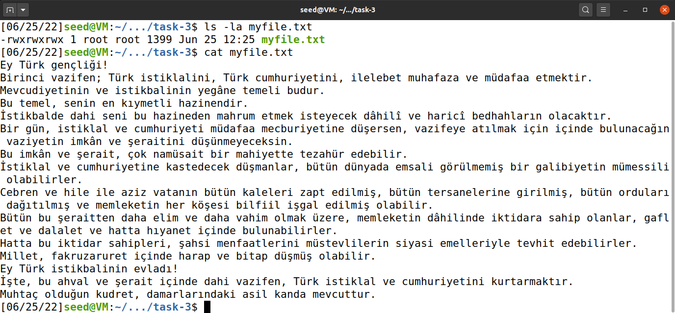

* **I encrypted this file using AES 128-bit block ciphers with ECB, CBC, CFB and OFB.**

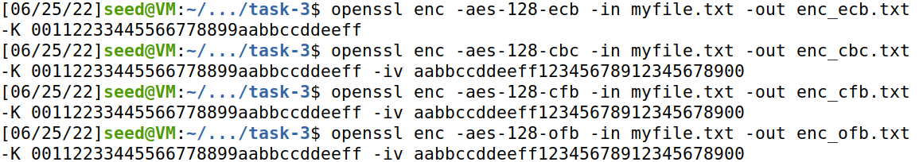

* **With Bless, I changed a bit on 55th byte of all encrypted txt files. For example in image below, selected byte (55th) was 8D. It corrupted to 8E. I saved all changes.**

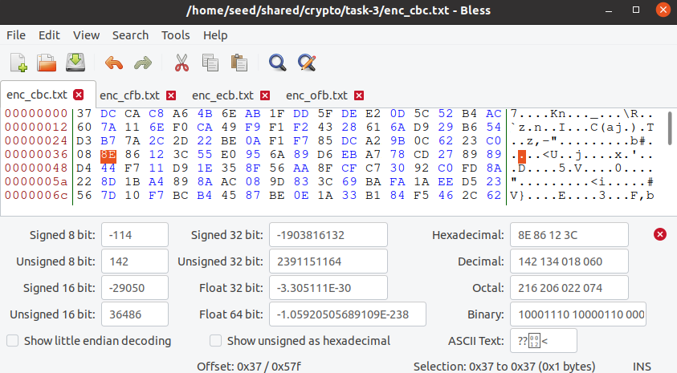

* **After corrupting, I decrypted all corrupted files with same keys and IVs.**

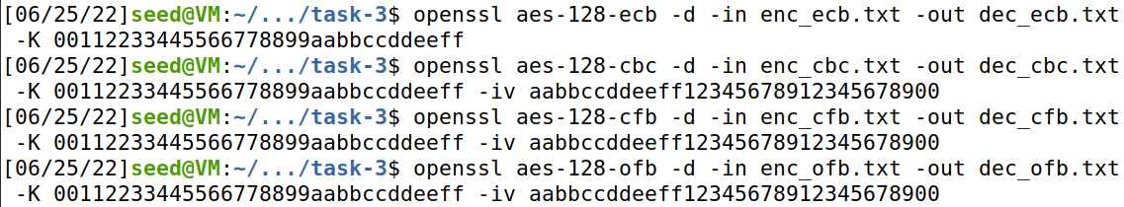

* **Errors (highlighted parts)**

My assumption was correct. The most data recovery is in OFB mode. In CBC and CFB modes, more data have been lost.

* + **ECB (little part in i’th block)**

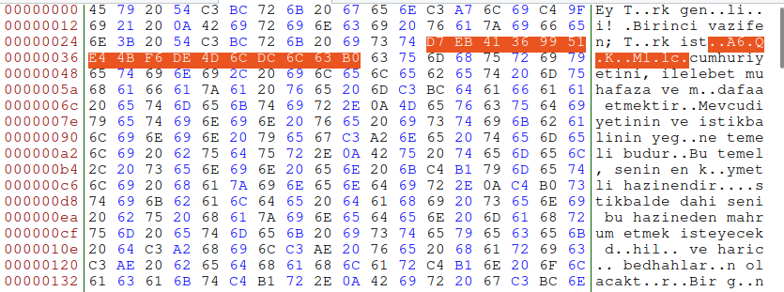

* + **CBC (i and i+1’th blocks)**

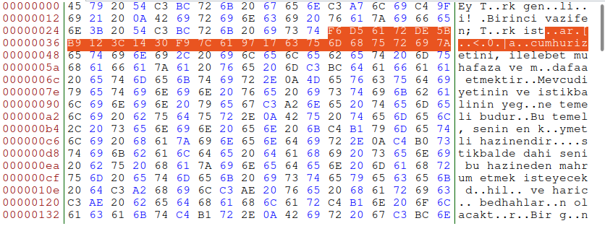

* + **CFB (i and i+1’th blocks)**

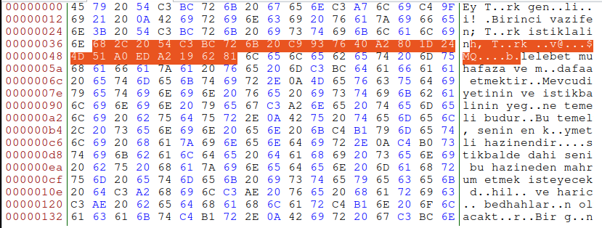

* + **OFB (only one bit in i’th block)**

